*Project Proposal*

*For*

School *Management System*

BCIS Department

Apex College

**POKHARA UNIVERSITY**

By

Prakash Majhi (16080033)

Rajina Dangol (16080038)

Nisha Pathak (16080028)

Sarishma Neupane (16080050)

Saurav Pokharel (16080053)

Kathmandu, Nepal

2019

To,

Research and Extension Centre

Apex College

Pokhara University

Kathmandu, Nepal

From:

Nisha Pathak (16080028)

Prakash Majhi (16080033)

Rajina Dangol (16080038)

Sarishma Neupane (16080050)

Saurav Pokharel (16080053)

Subject: Proposal for “School Management System”

In partial fulfillment of the requirement for

The degree of

*BACHELOR IN COMPUTER INFORMATION SYSTEM*Kathmandu, Nepal

July, 2017

# ABSTRACT

This project titled as "School Management System" is developed in PHP using HTML, Bootstrap, JavaScript and CSS. We have used core PHP as front end and SQL Developer and DBMS Server as back end. The main aim of the project is to control the management processes in school. The administrator will login to this project using the username and password. The administrator will enter the student details and every department worksheet. To begin with, proper management of time along with an effective and error – free atmosphere, school management software leave all the traditional techniques far behind. This is the best way to manage student information, student performance, student extracurricular activity, teacher response, classroom management, graduate information; report generation, etc. Student’s data and all other information of students and staff are held manually in files. In case of any robbery or an accident like a fire or any such mishap, you are left empty handed with no data with you. School management system simply removes the concept of those old big files and folders stored in large cupboards. The details will be stored in the database. The student details are entered and the department in which the student is placed are entered. School management system simply removes the concept of those old big files and folders stored in large cupboards. The administrator can view all reports in the project. The student reports, admission reports, fees reports are displayed as report to the administrator.

**Table of Contents**

**ABSTRACT i**

**CHAPTER 1 1**

**1.1 Introduction 1**

**1.2 Objectives 2**

**1.2.1 Academic Objectives 2**

**1.2.2 Other Objectives 3**

**1.3 Theoretical Background and Working Summary of Project 3**

**1.3.1 Theoretical Background 3**

**1.3.2 Overall Representation of the Project 3**

**1.3.2 Context Flow Diagram 4**

**CHAPTER 2 5**

**2.1 Literature Review 5**

**CHAPTER 3 6**

**3.1 Hardware and Software Requirement 6**

**3.1.1 Hardware Requirement: 6**

**3.1.2 Software Requirement: 6**

**3.1.3 CPU 6**

**CHAPTER 4 7**

**4.1 Proposed Schedule 7**

**CHAPTER 5 8**

**5.1 Cost Benefit Analysis 8**

**5.2 Benefits of ADMISSION MANAGEMENT SYSTEM 8**

**Chapter 6 9**

**Application of the Project in the Real World 9**

**Disadvantages of Present System 9**

**Proposed System 9**

**Chapter 7 10**

**Group Organization 10**

**List of Figures**

Figure 1 Overall Representation in Block Diagram 3

Figure 2: Context Flow Diagram of AMS 4

Figure 3: Gantt chart 7

**List of Abbreviation**

* HTML: Hyper Text Markup Language
* CSS: Cascading Style Sheet
* SQL: Structured Query Language
* DBMS: Database Management System
* PHP: Hypertext Preprocessor

# CHAPTER 1

## 1.1 Introduction

School Management System (SMS) helps any given school for the enrollment of new students. This process is very hefty and takes a lot of time. Also, it has been done manually in written format storing all the records and documents in the closets. School Management System allows you to manage the daily information of all the students easily along with student’s details. Based on the role, system should expose relevant options to the user. The School Management System focuses on storing and processing by using web pages. This system is used for the following:

* Generating student information in formatted html tables, student marksheet, class routines.
* Generating the student personal report, academic detail report and performance basis report.

School Management System has following impact on the schools while coming into existence and not coming into existence:

SMS while coming in existence:

* Data is stored with the help of software and filed with easy in the computer database.
* The software makes it faster, reduces the time and manpower and creates economic and accurate.
* Retrieval of information is with just clicks and fast.
* Management of admission procedure, admission form collection, listing and admitting student is done with the help of single data entry in the centralized database.

SMS while not coming in existence:

* Lot of paper work, filing and storage required.
* Manually procedure takes a good amount of manpower, it is uneconomical and inaccurate.
* Retrieval of information is full of efforts and time consuming.
* Management of admission procedure, admission form collection, listing and admitting student is a lengthy process in manual system.

Features & Advantages of Student’s School Management System

* Storing students’ school history (attendance, report card, ECA involvement) and certificates.
* On acceptance of admission process, automatic transfer of details of the student to school register and school records without any paper work.
* Get complete view of the student’s profile with photo
* Generate customized reports to get statistics of student performance.
* Make available class routine of every standard with the option to change routine in order to replace the absent faculty teacher.

## 1.2 Objectives

## 1.2.1 Academic Objectives

The following are the academic objectives of the project:

* To improve skills in internet technology and database management system
* To utilize the theoretical knowledge and bring it into practical form.
* For the partial fulfillment of the requirement for the degree of BCIS.

1.2.2 Other Objectives  
The following are the specific objectives of the project:

* To share and express our ideas and views regarding the project
* To encourage the schools and colleges for using the new technology and new record system for their smooth operation of the work

## 1.3 Theoretical Background and Working Summary of Project

### 1.3.1 Theoretical Background­­

To complete this project, we need theoretical knowledge regarding Internet technology mainly about Bootstrap, HTML, CSS and PHP. We also need knowledge about database management system.

### 1.3.2 Overall Representation of the Project

**Figure 1 Overall Representation in Block Diagram**

### 1.3.2 Context Flow Diagram

**Figure 2: Context Flow Diagram of AMS**

# CHAPTER 2

## 2.1 Literature Review

We as a team wanted to do something useful for our major project and after a lot of discussion after discussions we selected SCHOOL MANAGEMENT SYSTEM as our topic. We have been observing that management process has been really hectic work to be carried out manually. It’s really time consuming and kind of boring to file these all school daily activities curriculum processes. Looking at this hectic job and all those processes we thought of building a system that will make this daily processes many times easier than the previous one. It is configurable and can be configured to meet most school’s needs. Even today all the work of the student informations are done manually by ink and paper which is very slow and consuming much of efforts and time. So for easy and comfortable use, it is required to design a computerized automated student management system to speed up and make it easy to use the system. Student management system supports student detail information and other student activities, the maintenance of students’ personal, academic and related data. Database maintained by this system usually contains student personal, academic and fee related information (we will implement fee realated information in further future development).

To start any work, research is the most important thing to be done. So, for our project also we did a lot of research. And this research really help us to do the task in better way, gave us many more innovative ideas. We talked with some of our seniors and discussed about which project will be the best on for us and which can be useful even in daily lives. We were a bit confused on two topics and we even went to our project consultant sir to discuss about which topic would be best one.

We searched on internet about major project topics and came to a conclusion to do SCHOOL MANAGEMENT SYSTEM. After our topics were discussed, we did a lot of research on internet, visited many websites, and also watched some videos on how management process is executed on many schools.

# CHAPTER 3

## 3.1 Hardware and Software Requirement

### 3.1.1 Hardware Requirement:

* Keyboard
* CPU
* Monitor
* Mouse
* Internet Connection

### 3.1.2 Software Requirement:

* Operating system: Microsoft windows XP and above
* Front end tools: HTML, PHP, CSS, Bootstrap
* Back end tools: SQL Developer , DBMS Server

### 3.1.3 CPU

* Processor: Intel Dual Core and above
* RAM: 512 MB and above
* HDD: 40 GB and above

­

# CHAPTER 4

## 4.1 Proposed Schedule

The total working time for this project is about three and half months. This project starts from mid-July, 2017 and supposed to be finished by the first week of November. The work is divided into 4 phases. The first phase is problem identification which lasts about 15 days. The second phase is analysis which last about 10 days. Then we have our designing phase which is sub-divided into three part i.e. interfaces, process, and data, which lasts for about 45 days. The fourth phase is the most important phase which is coding and implementation. This phase lasts about 22 days or more. Then we have testing at the end of our project which last about 18 days after coding and implementation. With this schedule we can finish our project in time

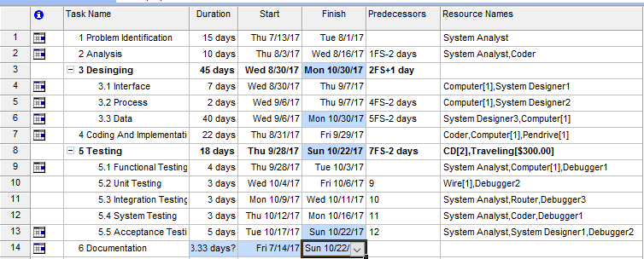

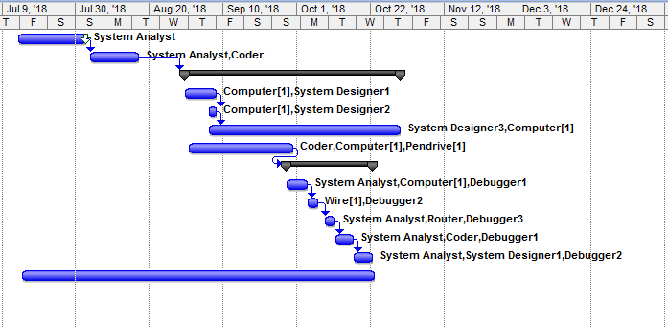

**Figure 3: Gantt chart**

# 

# CHAPTER 5

5.1 Cost Benefit Analysis  
The project cost estimation is the process of predicting the resources required for the development and completion the project. Fundamental question that are asked while estimating the cost are:

1. How much calendar time is it required to complete the project?
2. What is the total cost computed for an activity?

Various cost components are:

* Hardware and Software Cost
  + Development Cost
  + Programmer Cost

## 5.2 Benefits of SCHOOL MANAGEMENT SYSTEM

* Software systems are so much fast at performing task that means it saves time and efforts.
* Able to have instant access to all the information about every students, as well as additional documentation in order to make an informed decision.
* International admission will simply have to click a button to contact a student about missing information or deliver an application to the appropriate tutor.

# **Chapter 6**

Application of the Project in the Real World  
In present, all work is done manually by hand in bulk of files which is hard to operate and hard to maintain the reports of the student presently, took admission in institute.

* + When the student comes in school.
  + First of all, he/she takes admission form from reception.
  + Fills it and submits it into office.
  + Filled form is first checked with documents like merit list and details came from university and verified by an official person, if there is any mistake then it is corrected.
  + At the time of submission of it the fees is deposited by the candidate.
  + At the time of submission of admission form enrollment no. is assigned to the candidate by the institute.
  + Candidate gets the receipt of fees deposition.

## Disadvantages of Present System

* Require much man power i.e. much efforts, much cost and hard to operate and maintain.
* Since, all the work is done in papers so it is very hard to locate a particular student record when it is required.

## Proposed System

1. It is automated computerized web based software system.
2. It uses latest technologies like ASP.NET and SQL Server.
3. It is easy to operate.
4. Attractive User Interface.

Hence, this proposed system is really needed and useful system required in today’s schools/and colleges. This system is very much applicable in today’s world.

# Chapter 7

## Group Organization

Group means two or more people working together through interaction, having a common goal or objectives and specifically having individual responsibility that helps in completion of group’s objective. Group organization means co-operation and mutual interaction among the group members. So, to complete any task or project in a better way group co-ordination is the must.

For this project also we were divided into groups and each group has five members. Our group with project topic “SCHOOL MANAGEMENT SYSTEM” has the following members Prakash Majhi, Rajina Dangol, Nisha Pathak, Sarishma Neupane and Saurav Pokharel.

We as a team has chosen Mr. Saurav Pokharel as our Group leader because we think that he has the potential to be a group leader and he was the one who convinced all of us to do the minor project on this topic. So we think that he could handle the project taking the leader responsibility.

As a team leader Saurav will be guiding all of us. He will be helping all of us whenever help is required. Saurav will be informing all of us about the project updates. He will also be engage in all these cost estimation, Gantt chart. Deebya will be more engaged communicating with the team members about the ongoing process in project. She along with Sarishma and Nisha will be engaged in research works.

Here, in our project each and every member will be contributing equally as required by our project. The work division is as follows:

**Problem Analysis, Requirement and Feasibility Phase:**

Prakash Majhi

Sarishma Neupane and Nisha Pathak

**Front-End and Back-End Designing**

Saurav Pokharel and Prakash Majhi